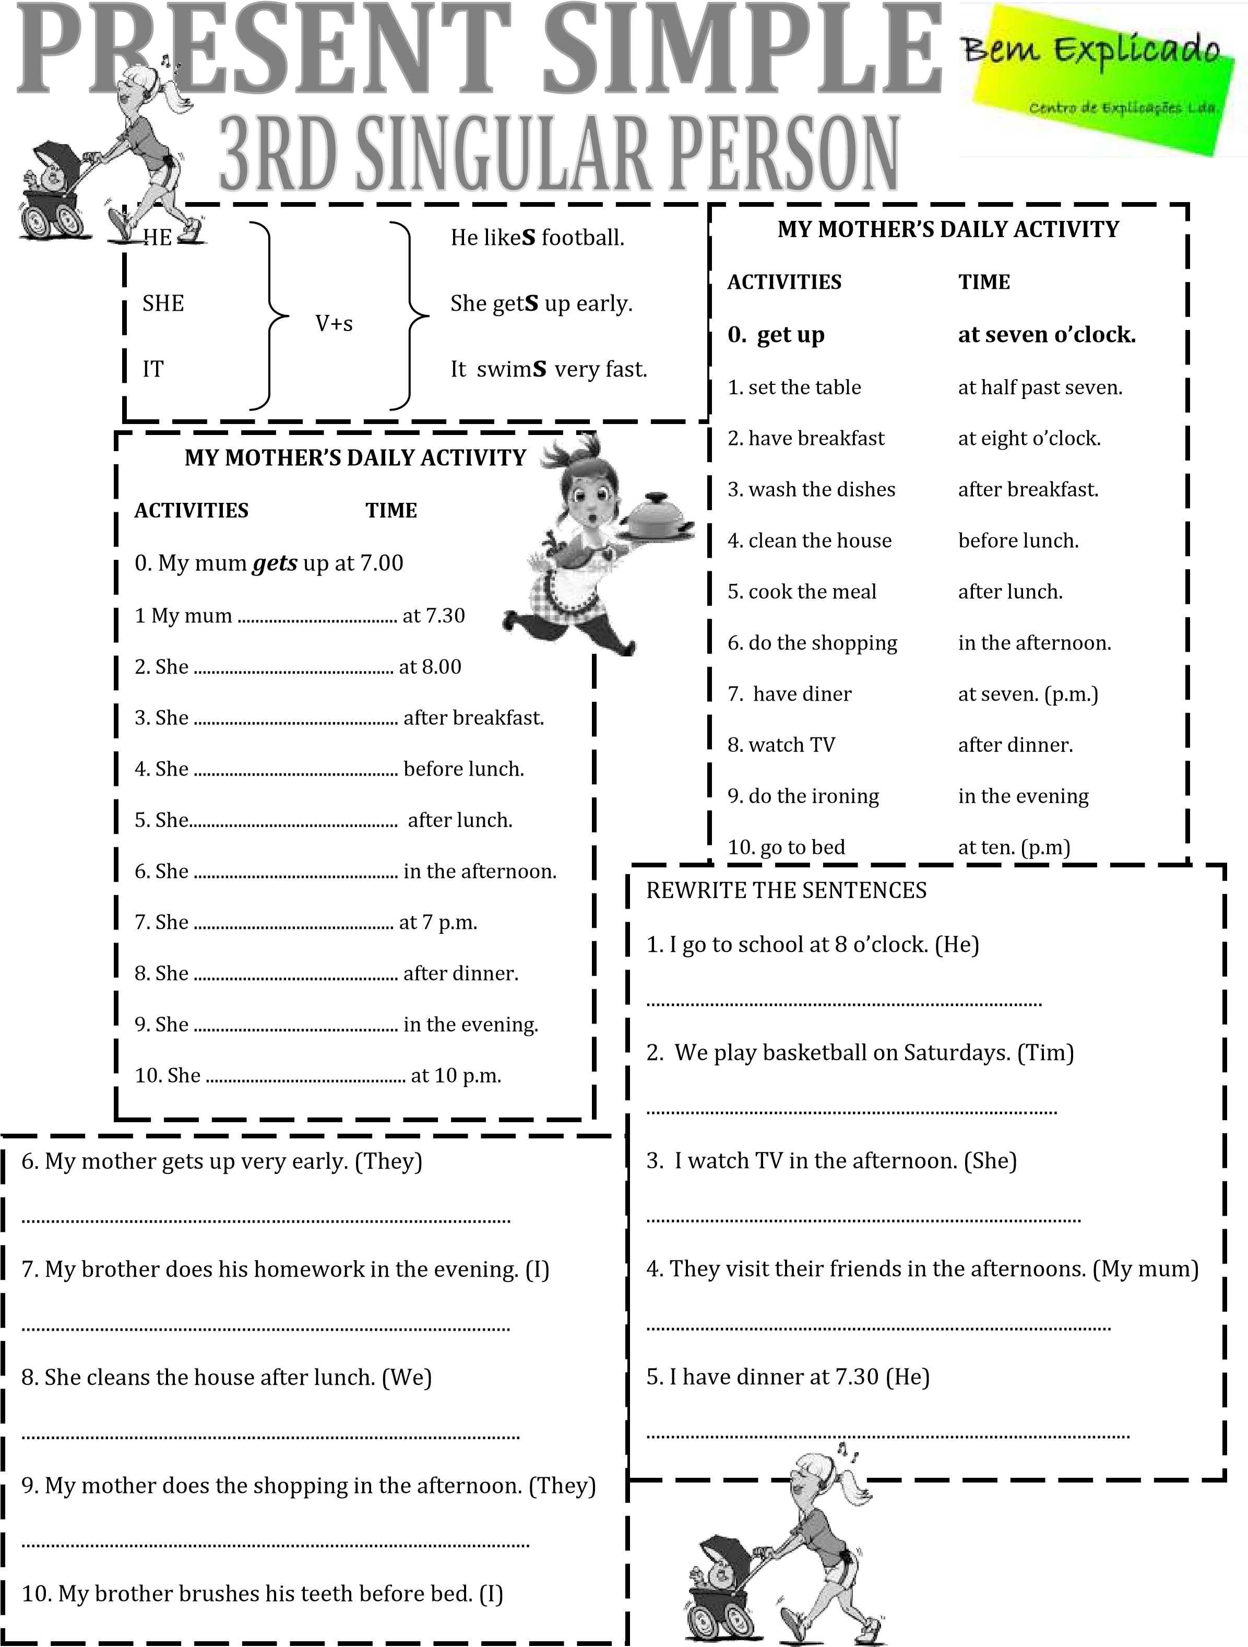

has breakfast

washes the dishes

does the shopping

has dinner

watches tv

does the ironing

goes to bed

sits at the table

I brush my teeth before bed

I do my homework in the afternoon

She watches TV in the afternoon

My mum visits their friends in the afternoons.

They get up too early

He has dinner at 7.30

Tim plays basketball on Saturdays

He goes to school at 8 o’clock

They do the shopping in the afternoon

We clean the house after lunch

cooks the meal

cleans the house